P
Dr. Durlav Sarkar
MBA, FDP (IIM-A),Ph.D.
Registrar, Raiganj University
Raiganj, Uttar Dinajpur
West Bengal, India-733134
Email ID: registrar@raiganjuniversity.ac.in
durlavsarkar1@gmail.com

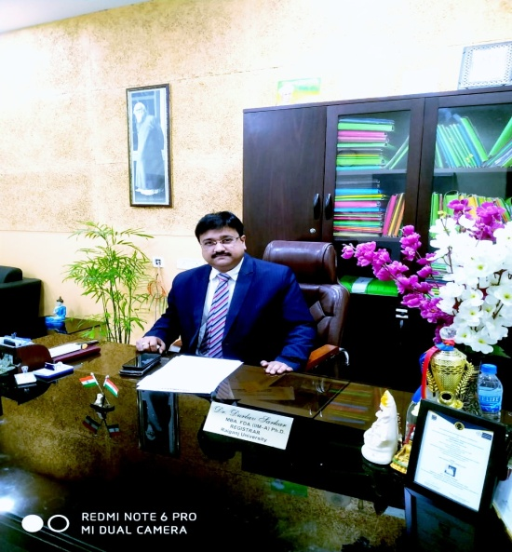

Dr. Durlav Sarkar is presently working as Registrar at Raiganj University, Raiganj Uttar Dinajpur, West Bengal w.e.f 19.01.2018. Raiganj University is a state aided University under Govt. of West Bengal as per the Raiganj University Act, 2014 passed in Assembly and this University is affiliated to UGC, New Delhi.

Formerly Dr. Sarkar was working as Associate Professor in Management in Royal University of Bhutan and before that he was working as Professor & Director at Delhi School of Professional Studies and Research, New Delhi Under Guru Gobind Singh Indraprastha University (GGSIPU). He acted as Head, Dept of Management at DSMS Business School, Durgapur West Bengal under WBUT and worked as a Lecturer in University of North Bengal, and other Universities in different teaching positions.

Dr. Sarkar completed his Ph.D. from University of North Bengal, West Bengal in the year of 2012. Being a Management scholar Dr. Sarkar has completed his MBA degree from University of Kalyani, West Bengal and completed FDPM from Indian Institute of Management-Ahmedabad.

Having more than 18 years of teaching, research, consultancy , administrative and Industry experience Dr.Sarkar has published 2 books, more than 15 research articles in National and International Journals and presented more than 21 research papers and attended workshops in different levels.
Dr. Sarkar was the Editor of a Peer Reviewed Management Journal titled ‘CALYX Journal of Business management’ (ISSN No: 2229-4260) and reviewed a book on “Vedanta for Modern World” jointly authored with Prof . Ajay Kr. Singh , Professor, Delhi School of Economics and it was published in Delhi Business Review ,December,2014.

Dr.Sarkar was the Director of Delhi School of Professional Studies and Research, New Delhi and successfully managed the Institute under GGSIPU, New Delhi during 2014-15.

Being Registrar of Raiganj University Dr.Sarkar is looking after the administrative works of the state aided University which is a big University and having more than 12000 students at Raiganj, Uttar Dinajpur, West Bengal.

