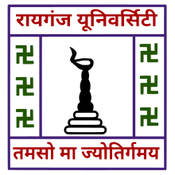
RAIGANJ UNIVERSITY
Department of Sociology
P.O.: Raiganj, Dist.: Uttar Dinajpur, West Bengal, Pin- 733134, India

Department of Sociology <sociologyrgu@gmail.com>

24.01.2022

It is hereby notified that a What’s App group has been created by the Department of Sociology in accordance with the list (provided by P.G. Council Secretary, Raiganj University) containing the names of P.G. 1st Semester Students who have Sociology as their GE paper. If any student (of the mentioned Semester) who are finally allotted with Sociology as GE, has not yet been included in this group are requested to immediately contact in the given number (M:9836776210).

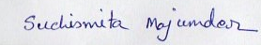
Dr. Suchismita Majumder
Coordinator,
Department of Sociology,
Raiganj University.

